Theory of Plate Tectonics
The Lithosphere is broken down into many large pieces called tectonic plates.
These plates move slowly over Earth’s surface carrying continents and seafloor with them.
Tectonic plates move 1cm to 10 cm per year. These slow movements over millions of years changed Earth’s surface significantly.
The edges of continents are not always in the same places as the edges or boundaries of plates.
Some plates are almost entirely covered by oceans. (Pacific Plate)
Other plates consist mainly of continents. (North American Plate)
Plates move because the dense rock near their edges is pulled into the mantle by gravity.
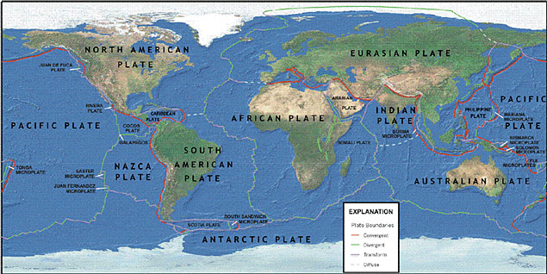
What Happens at Plate Boundaries?
Most volcanoes and earthquakes occur at plate boundaries.
Mountains and deep valleys commonly form at plate boundaries.
Based on how the plates are moving they are classified into three groups:
Divergent, Convergent, and Transform boundaries.
Divergent-two plates move apart
Convergent-two plates are moving toward each other
Transform-two plates moving past each other horizontally.
Divergent Boundaries

Convergent Boundaries

Three main kinds of convergent boundaries.
- Continental-oceanic convergent boundary

- Oceanic-oceanic convergent boundary

- Continental-continental convergent boundary.

Transform Fault Boundaries

Type of Convergent Boundary | Structures Formed | Example

Define terms:
- Fault

- Subduction

- Subduction zone

- Mid-ocean ridges

Type of Plate Boundary | Draw what it looks like

Give an example of each type:

Earthquakes and Volcanoes
When rocks slide past one another at a fault, the resulting vibrations are
__________________________.
Earthquakes are related to _____________ ______________________.
As tectonic plates _______________ their edges experience stress. If part of a
plate cannot move freely, ________________ from the stress on the rocks
_____________ _______. At the point where the stress becomes so great the
rock _______________ along a __________________, causing an ______________________.

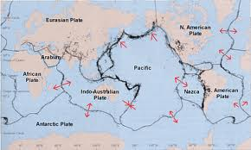

What Happens When Rock Breaks?
When rock breaks during an _______________________, energy is released. The
energy travels through the earth as __________________ ________________.
Seismic waves travel _______________ earth and along its ____________________.
Seismic waves produce the ____________________ we experience during an earthquake.
The _____________ of an earthquake is the point inside Earth where rock
__________________. Seismic waves travel in all directions from the focus. In
most cases, the focus is located below Earth’s surface.The point on the
surface directly above the focus is the _________________________.
________________________ from an earthquake is often greatest near the
Epicenter, but may also occur many kilometers away.
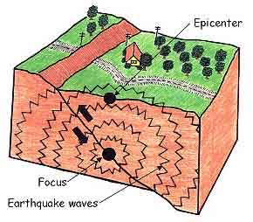
Three Types of Seismic Waves
P waves

S waves

Surface waves

